VISVESVARAYA TECHNOLOGICAL UNIVERSITY
JNANA SANGAMA, BELAGAVI- 590 018

“AICTE Activity Point Programme”

Submitted in Partial Fulfillment for the Award of Degree of
Bachelor of Engineering
in
Computer Science and Engineering

Submitted by
SAGAR MOKASHI
2TG23CS071

Department AICTE Activity Faculty Incharge

NSS Officer/AICTE Co-Ordinator of the college



Department of Computer Science and Engineering
Tontadarya College of Engineering
Mundaragi Road, GADAG – 582 101
2025-2026

AICTE Activity Point Programme
CERTIFICATE
This is to certify that the AICTE Activity Point Programme has been successfully carried out by SAGAR MOKASHI bearing 2TG23CS071, Bonafide student of Tontadarya College of Engineering in partial fulfillment of the requirements for the award of degree of Computer Science and Engineering of Visvesvaraya Technological University, Belagavi during year 2025-2026. It is certified that all corrections/suggestions indicated for Internal Assessment have been incorporated in the report. The AICTE Activity Point Programme report has been approved as it satisfies the academic requirements in respect of AICTE Activity Point Programme for the said degree.

__________________  Signature  Name  Faculty Incharge | __________________  Signature  Name  Department HOD | __________________  Signature  Name  AICTE Activity Points  Co-Ordinator of the College | __________________  Signature  Name  Principal

DECLARATION

I, SAGAR MOKASHI bearing the 2TG23CS071, Student of Bachelor of Engineering, Computer Science and Engineering , Tontadarya College of Engineering, Gadag, hereby declare that the AICTE Activity Point Programme work has been carried out by me under the supervision and guidance of Department Staff Coordinators submitted by me as a partial fulfilment for the award of Bachelor of Engineering degree in Computer Science and Engineering from Visvesvaraya Technological University, Belagavi during 2025-2026.

I hereby declared that the AICTE activity point work has been carried out at following partner organizations:

- ……………………..
- …………………….
- …………………….

Signature
SAGAR MOKASHI
2TG23CS071

ACKNOWLEDGEMENT

I extend my heartfelt gratitude to the [Trustees/Management/Board Members], along with M M Awati, Principal of Tontadarya College Of Engineering, Gadag ; [Name of Professor], Professor at [College Name]; and [Name of Coordinator], AICTE Activity Points Coordinator at [College Name], for their unwavering support and provision of essential resources for the successful execution of this program.
I am also deeply thankful to [Name of NGO/Organization/Trust] for their invaluable support in offering meaningful volunteering opportunities and resources.
Lastly, I would like to express my sincere appreciation and respect to my parents, the teaching and non-teaching staff of the Department, and all my friends who have supported me, directly or indirectly, throughout my AICTE Activity Point Programme journey.

SAGAR MOKASHI
2TG23CS071

Work Content

Sl. No. | Activity Heads | From date  to date | Number of Week | Total No  of Hours | Performance Appraisal / Points earned  (To be Filled by Coordinators) | Remarks
1 | Developing Sustainable Water Management system | To | 21 | 840
2 | Contribution To any national level initiative of Government of India, For e.g. Digital India/ Skill India/ Swachh Bharat Internist etc | To | 17 | 680
TOTAL ACTIVITY POINTS EARNED

ABSTRACT

This report presents the activities completed under the AICTE Activity Point Programme during the academic year 2025–2026. The programme included two major tasks: Sustainable Water Management and Contribution to Swachh Bharat Abhiyan.

Each activity helped in gaining practical knowledge and understanding social responsibility. The water management activity provided exposure to irrigation systems and the importance of conserving water. Participation in Swachh Bharat Abhiyan promoted hygiene, cleanliness, and public awareness.

These activities helped develop teamwork, leadership, environmental awareness, community engagement, and practical skills. Overall, the programme provided valuable learning beyond the classroom and encouraged active participation in nation-building efforts.

CHAPTER-1
DEVELOPING SUSTAINABLE WATER MANAGEMENT SYSTEM

1.1 Introduction
Sustainable Water Management has become essential due to increasing water scarcity, pollution, and the rising demand for clean water. With climate change and population growth putting pressure on water sources, it is important to adopt practices that protect and conserve water for both present and future generations.

To address this, our college organized an AICTE Activity on “Developing a Sustainable Water Management System” under the guidance of Prof. Adokshaja Kulrani. Students were introduced to water conservation techniques, rainwater harvesting concepts, and the importance of reducing wastage. Activities like campus water audits, awareness drives, poster creation, and leakage identification helped students understand real-world challenges.

This initiative encouraged students to become responsible and aware about sustainable practices. It provided practical experience, improved teamwork, and strengthened environmental values. Through this program, students learned that even small actions—like closing taps properly or reusing water—can make a meaningful difference in building a sustainable future.

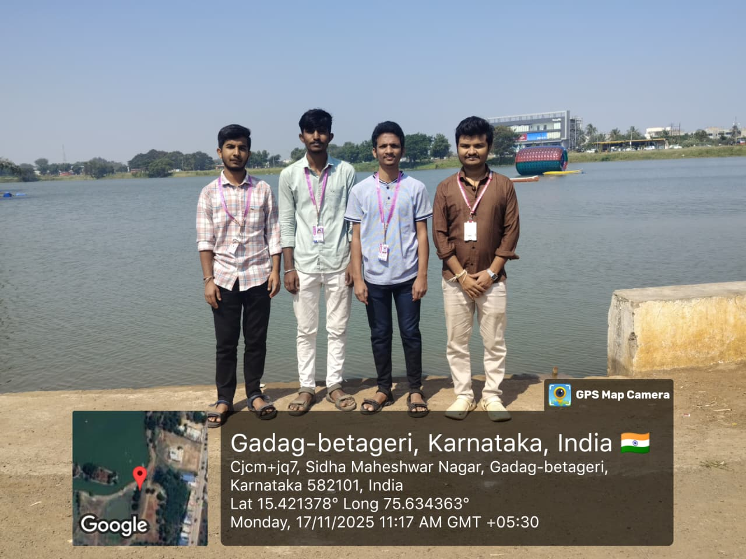
1.2 The Beginning of Sustainable Water Management Efforts
The initiative began with the objective of understanding how water is used, wasted, and conserved within our surroundings. Students were introduced to the basics of sustainable development, water conservation principles, and the importance of protecting fresh water sources. Our journey started with simple steps such as conducting water audits, identifying leakage points, studying water storage systems, and collecting data on daily usage.
Slowly, larger activities such as awareness campaigns, campus surveys, and clean-up drives were organized. These efforts helped students recognize the urgent need for adopting long-term sustainable solutions like rainwater harvesting, efficient water distribution, and recycling.
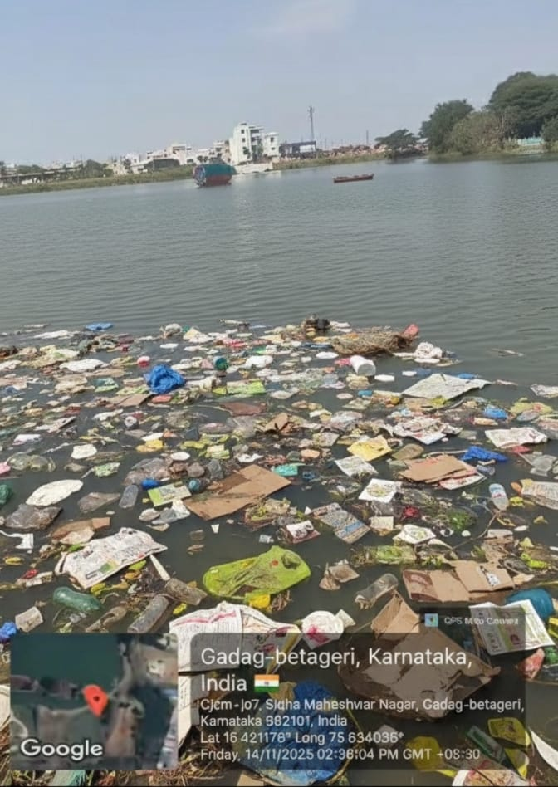

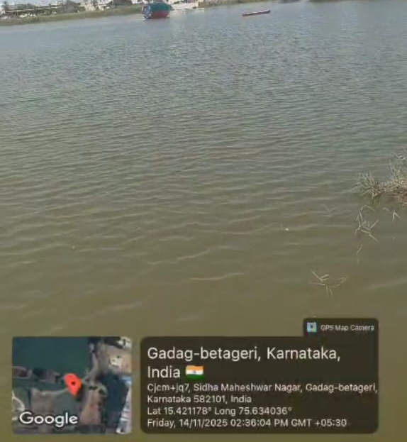

1.3 Awareness and Public Participation
Awareness and community engagement form the backbone of any sustainable water initiative. To involve students, staff, and the public, several activities were conducted:
- Posters and banners on “Save Water, Save Life”, “Every Drop Counts,” and “Use Water Wisely.”
- Awareness rallies and classroom sessions explaining the harmful effects of water wastage.
- Demonstrations on simple water-saving techniques like turning off taps, using buckets instead of showers, and reusing treated water.
- Digital awareness using social media posts, videos, and QR-linked water-saving tips.
Public participation increased gradually as people became more aware of the consequences of water scarcity and the need for individual responsibility.

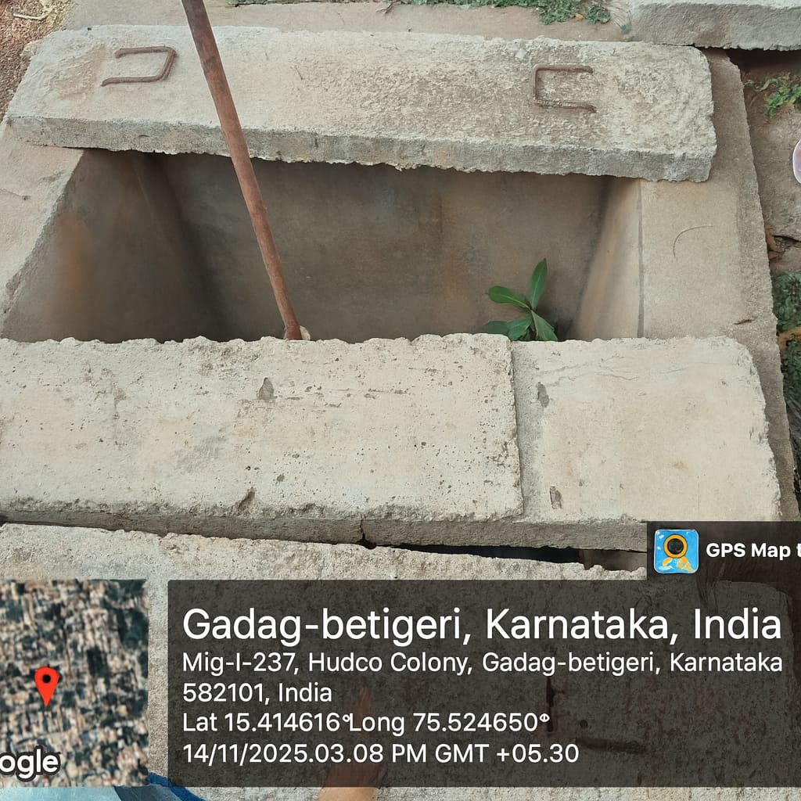

1.4 Environmental and Social Impact
The sustainable water management activities created significant environmental and social benefits:
- Reduction in water wastage due to repairs of leakages and better monitoring.
- Cleaner surroundings due to combined Swachh Bharat activities, reducing pollution in water sources.
- Improved greenery in the campus due to better irrigation planning and reuse of water.
- Students developed environmental ethics, teamwork, and responsibility toward natural resources.
Socially, the initiative encouraged collective behavior, influenced students' daily habits, and motivated them to conserve water at home and in public places.
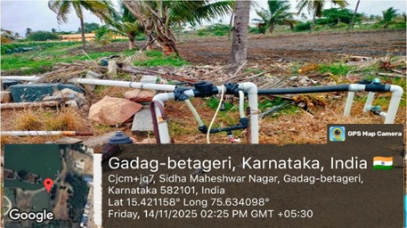

1.5 Technological Interventions and Innovation
Technology played a crucial role in enhancing the efficiency of water management efforts. Some key interventions included:
- Use of digital tools like Google Forms, mobile apps, and sensors for data collection.
- GPS-based mapping of water points around the campus.
- Use of water flow meters where possible to measure consumption.
- Digital posters, presentations, and awareness videos created using designing tools.
- Exploration of low-cost innovations such as rainwater harvesting models, slow drip irrigation using plastic bottles, and greywater recycling ideas.
These tools helped in accurate data analysis, better decision making, and improved planning for sustainable water usage.

1.6 Conclusion
The development of a Sustainable Water Management System is not just an activity but a long-term vision. Through this initiative, students learned the importance of protecting water resources and adopting sustainable practices. The combined efforts of teachers, students, and volunteers contributed to creating an environmentally responsible culture on the campus. With continuous awareness, technological innovation, and community participation, a sustainable water future can be achieved for the coming generations.

CHAPTER 2
CONTRIBUTION TO SWACHH BHARAT ABHIYAN

2.1 Overview
As part of our contribution to the national mission Swachh Bharat Abhiyan, our team carried out a dedicated cleanliness activity within and around the college premises. The purpose of this activity was to promote cleanliness, hygiene, and environmental responsibility among students.
Instead of conducting rallies or awareness marches, we focused purely on practical, on-
ground cleaning work. Students voluntarily took part in removing litter, collecting waste, clearing dry leaves, and cleaning corners that are usually neglected.

The activity helped in improving the overall cleanliness of the surroundings while also encouraging students to actively participate in maintaining a clean and healthy environment.
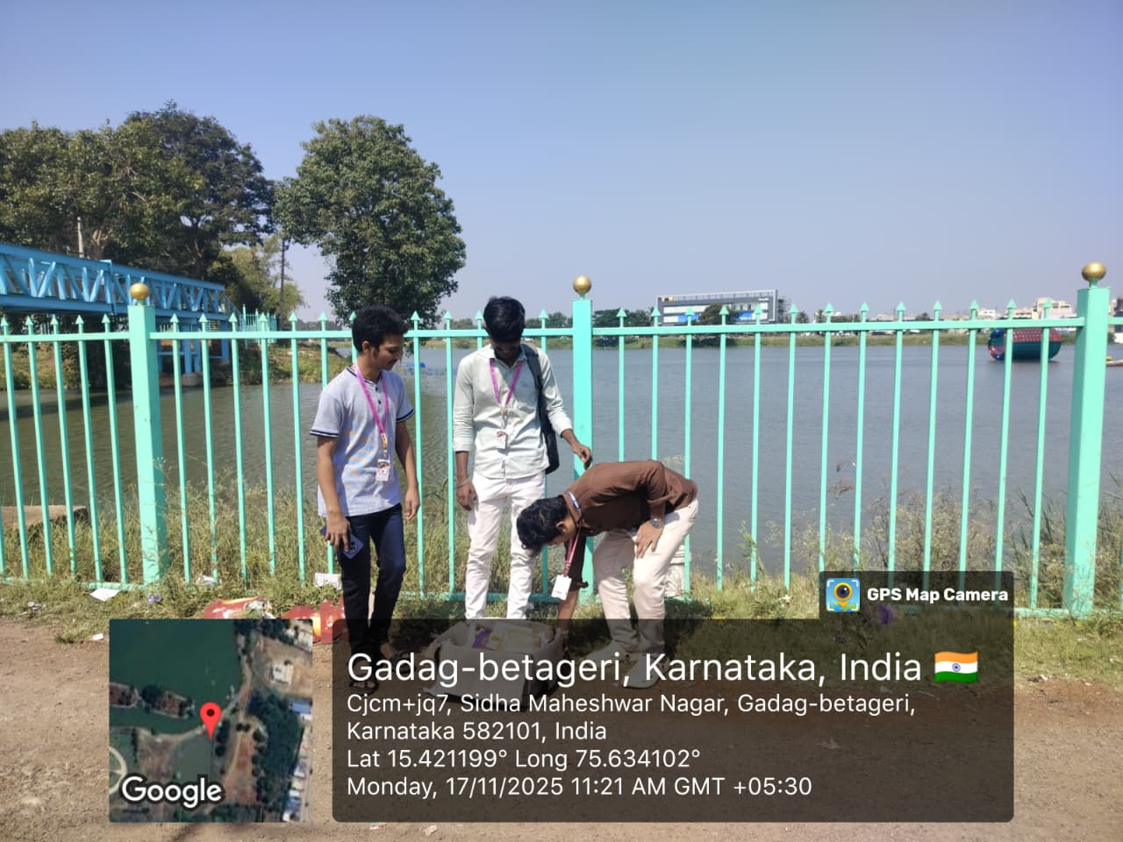

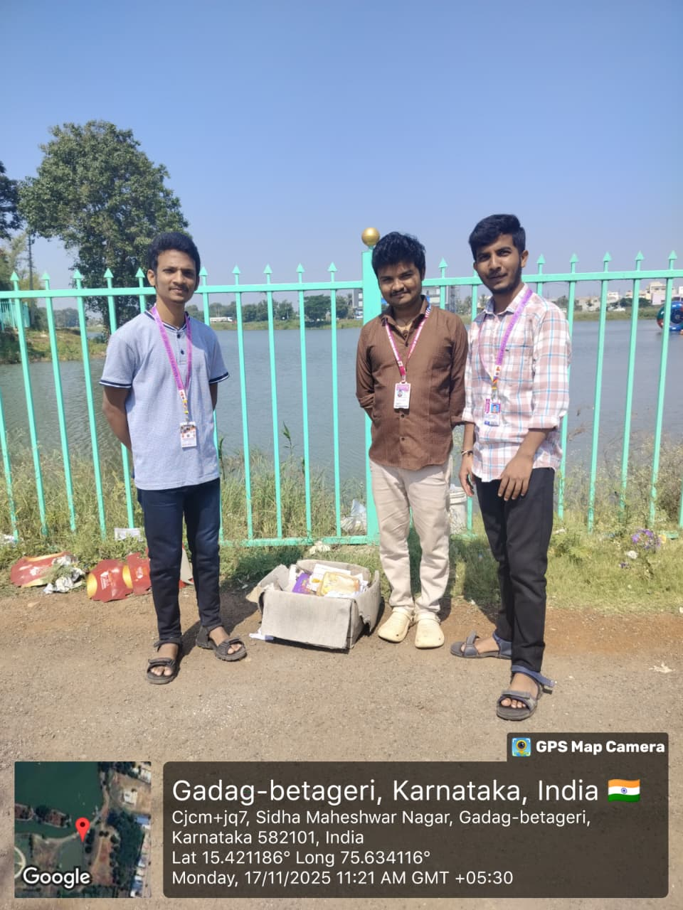
2.2 Objectives of the Activity
- To motivate students to adopt cleanliness as a daily habit.
- To support the Swachh Bharat Mission through practical action.
- To create awareness about proper waste disposal.
- To build teamwork and social responsibility among students.

2.3 Cleaning Activities Conducted
The following tasks were performed during the activity:
- Cleaned open areas.
- Swept dusty areas and collected dry leaves from the ground.
- Removed plastic bottles, wrappers, and other non-biodegradable waste.
- Collected garbage in bags and handed it over to the waste management team.
- Organized the cleaned area for better appearance and hygiene.
Students worked in groups, ensuring that each area was properly cleaned and inspected.

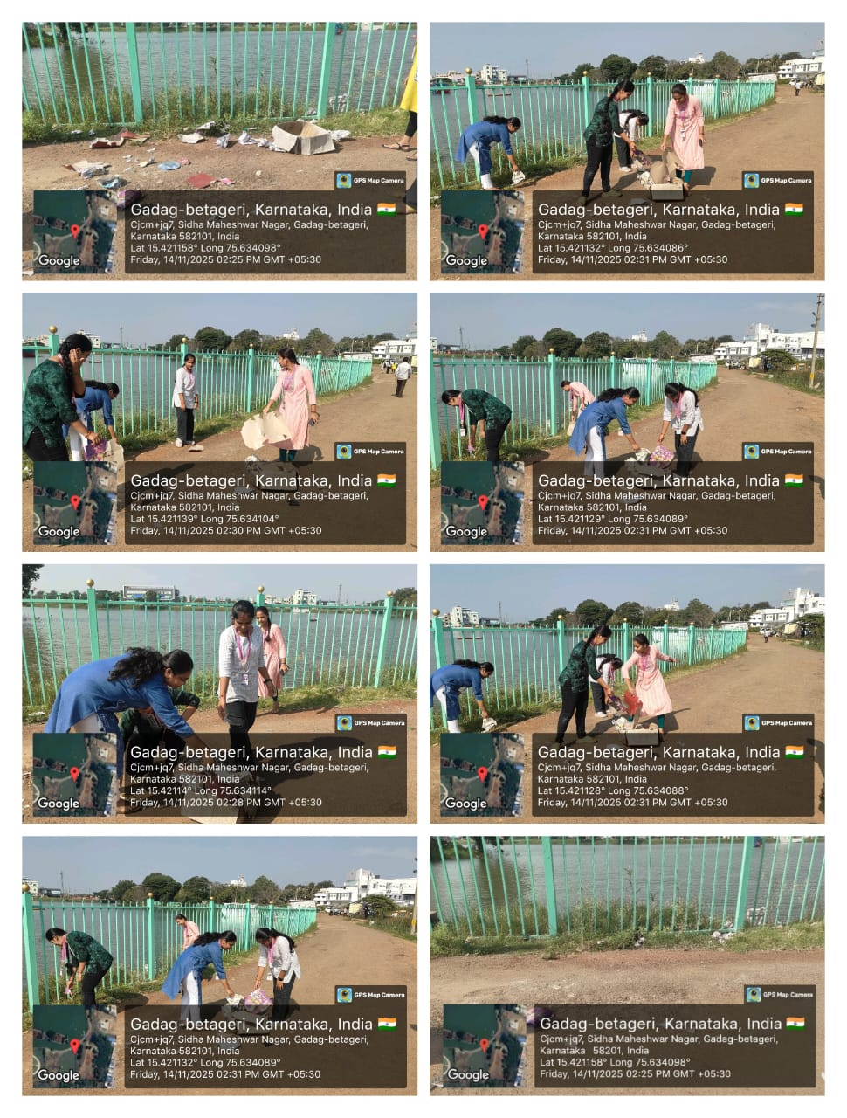
2.4 Sustainable Practices Followed
Even though the activity was a simple cleanliness drive, sustainable best practices were included:
- Encouraged waste segregation for proper disposal.
- Cleaned clogged areas to avoid waterlogging.
- Made students aware of how unhygienic surroundings affect water quality.
- Ensured no burning of waste—everything was properly collected and disposed.
This connected the activity with overall environmental sustainability.

2.5 Outcomes of the Activity
- Campus surroundings became cleaner, healthier, and more presentable.
- Students developed a sense of responsibility towards public cleanliness.
- Improved understanding of the importance of proper waste management.
- Strengthened teamwork and cooperation among students.
- Motivated students to maintain cleanliness regularly, not just during events.

2.6 Conclusion
The cleaning activity under Swachh Bharat Abhiyan was simple but highly impactful. It made students realize that cleanliness starts from oneself and even small efforts can contribute to a cleaner environment. The activity strengthened the idea that the Swachh Bharat Mission is not just a government initiative but a collective responsibility of every citizen.

